Merck Life Science KGaA . Frankfurter Str. 250 . 64293 Darmstadt . Germany

To Whom It May Concern _{Date} 20 February 2023
Division/Dept. Global Export Operations
Care of
Phone
Fax
E-Mail

Distributorship Authorization
We, Merck Life Science KGaA, being a subsidiary of Merck KGaA, Darmstadt, Germany, Frankfurter Strasse 250, 64293 Darmstadt, Germany, confirm on our behalf and on behalf of our affiliates

Sigma – Aldrich Israel Ltd., 3 Plaut Street, Rabin Park, 76100 Rehovot, Israel,
Millipore S. A. S., 39, route Industrielle de la Hardt, 67120 Molsheim, France and Merck LS RTU GmbH, Goebelstrasse 1-3, 64293 Darmstadt, Germany

that the company

Mercury Scientific & Industrial Products Ltd.
Ha`avoda Street 12
ROSH-HA AYIN 48101
Israel

is an authorized distributor in ISRAEL for

SCIENCE & LAB SOLUTIONS
- LA1 Lab Water Solutions
- LA2 Biomonitoring
- LA4 Diagnostics & Regulated Materials

Merck Life Science KGaA  Frankfurter Straße 250  64293 Darmstadt · Germany  Tel. +49 6151 72 0  Fax +49 6151 72 2000  MERCKgroup.com | Corporation with General Partners  Commercial Register: AG Darmstadt HRB 104168  Registered Office: Darmstadt  Chairman of the Supervisory Board:  Wolfgang Büchele  General Partner: Merck KGaA  Commercial Register of Merck KGaA:  AG Darmstadt HRB 6164 | Registered Office of Merck KGaA: Darmstadt  Executive Board and General Partners of Merck  KGaA: Belén Garijo (Chair), Kai Beckmann, Peter Guenter, Matthias Heinzel, Marcus Kuhnert Chairman Supervisory Board of Merck KGaA:  Wolfgang Büchele

- LR2 Chemistry
- LR4 Biology

PROCESS SOLUTIONS
- LP2 BioProcessing
- LP3 Process & Formulation Materials

Mercury Scientific & Industrial Products Ltd. is entitled to participate in local tenders and to offer and sell Life Science products mentioned in the paragraph above, in original packages and originally labelled, from their local stock.

This authorization is valid until 31.12.2023.

With best regards

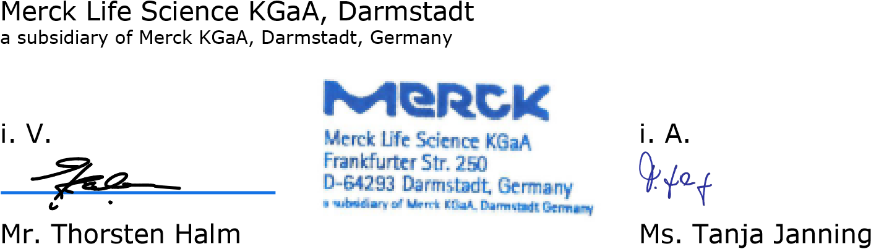Thorsten Halm (Feb 20, 2023 22:33 GMT+1)
Head of Global Export Operations Sales Programs
Life Science | EMEA Life Science | EMEA

